Name:- Shrutika Ananda Mungurwadi

Roll No.:- CS7-15

PRN:- 202401080067

Subject:- EDS

**ACTIVITY -1**

1. **Load the Dubai hotel review dataset into a dataframe.**

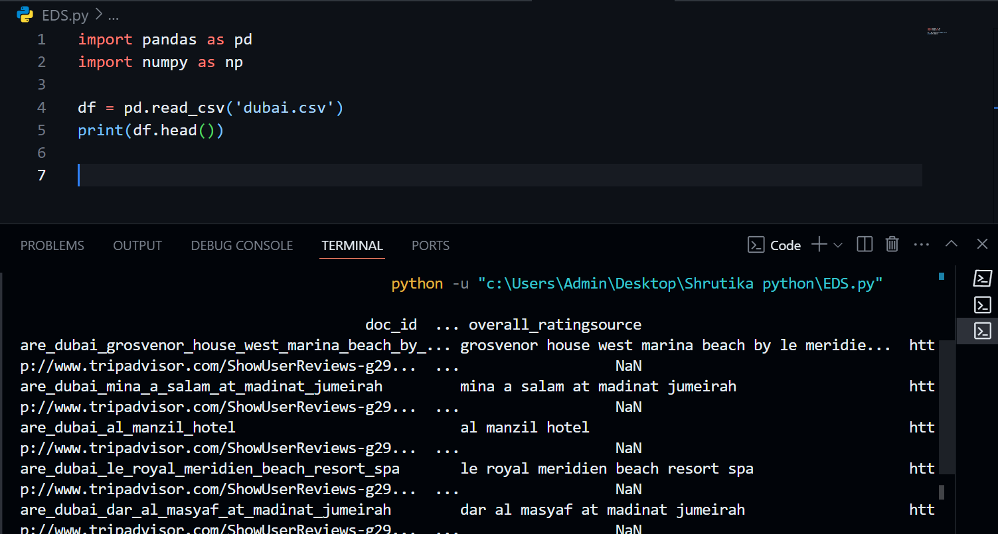

1. **Show the first 5 rows of the dataset.**



1. **Check the number of rows and columns in the dataset.**

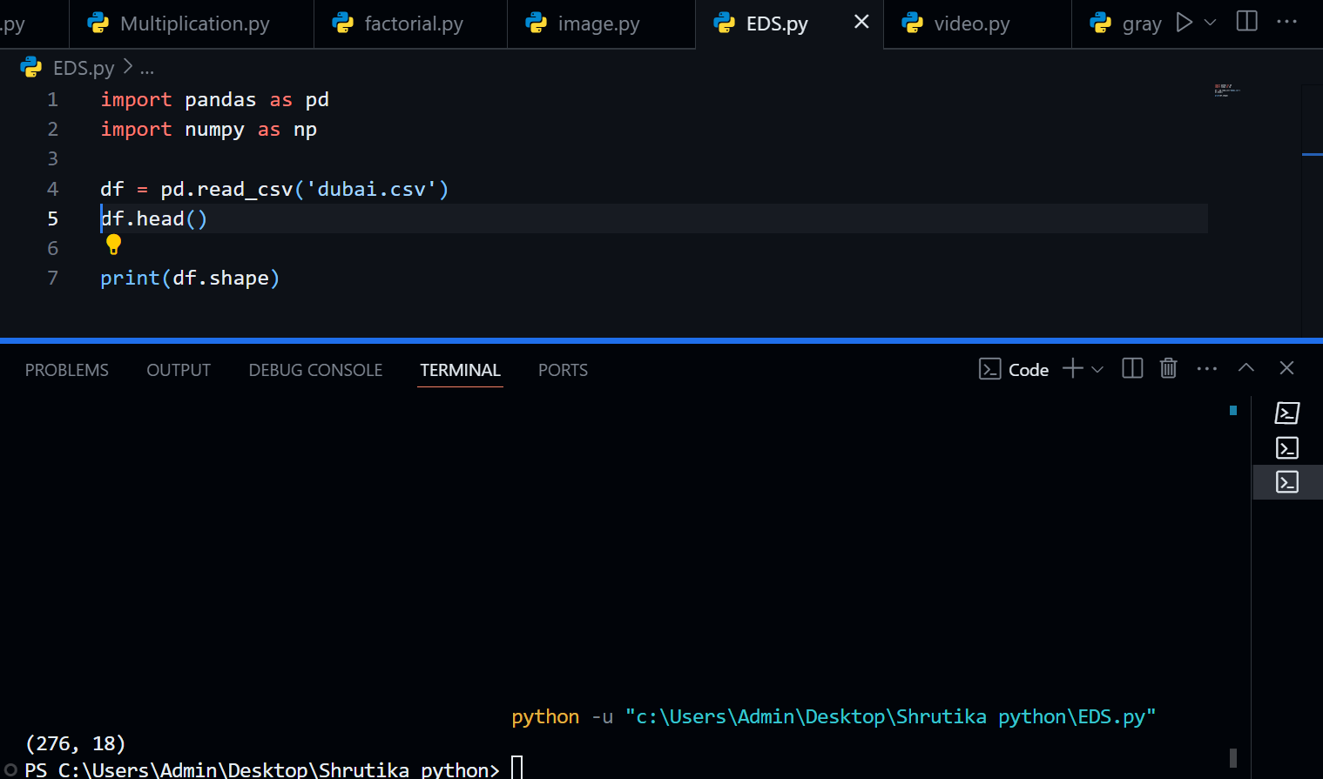

1. **Get all column names of the dataset.**

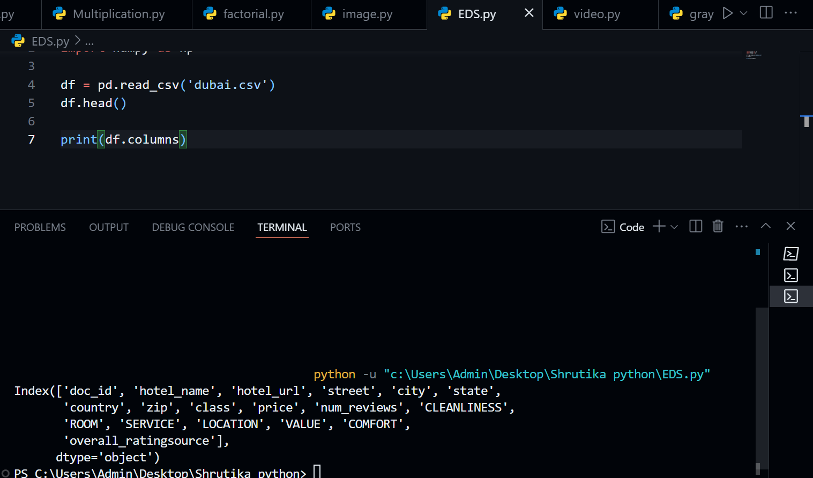

1. **Find how many missing (null) values are present in each column.**

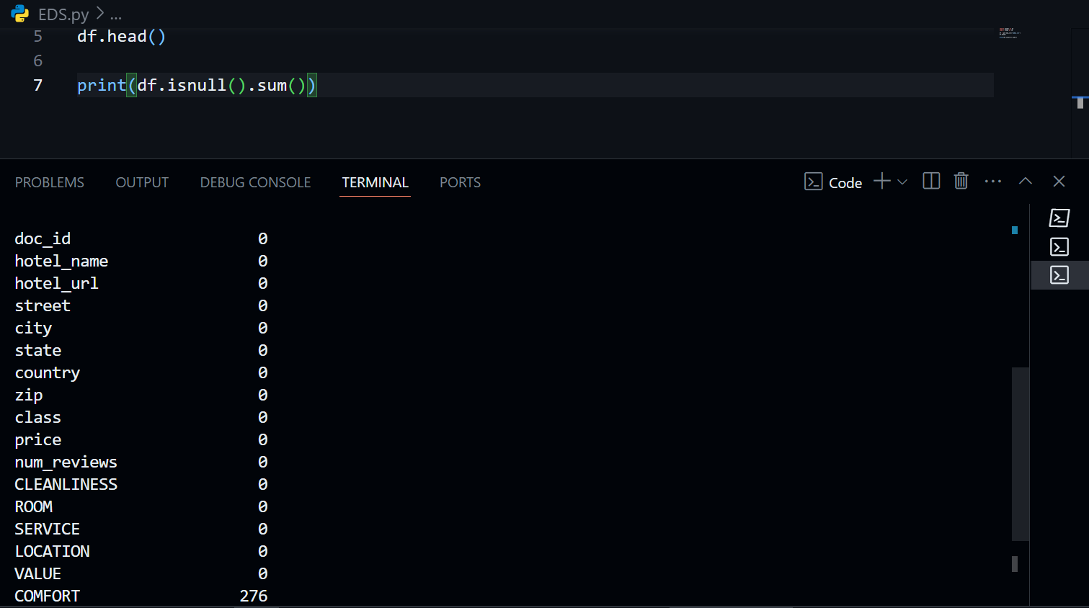

1. **Display basic statistical details of the numerical columns.**

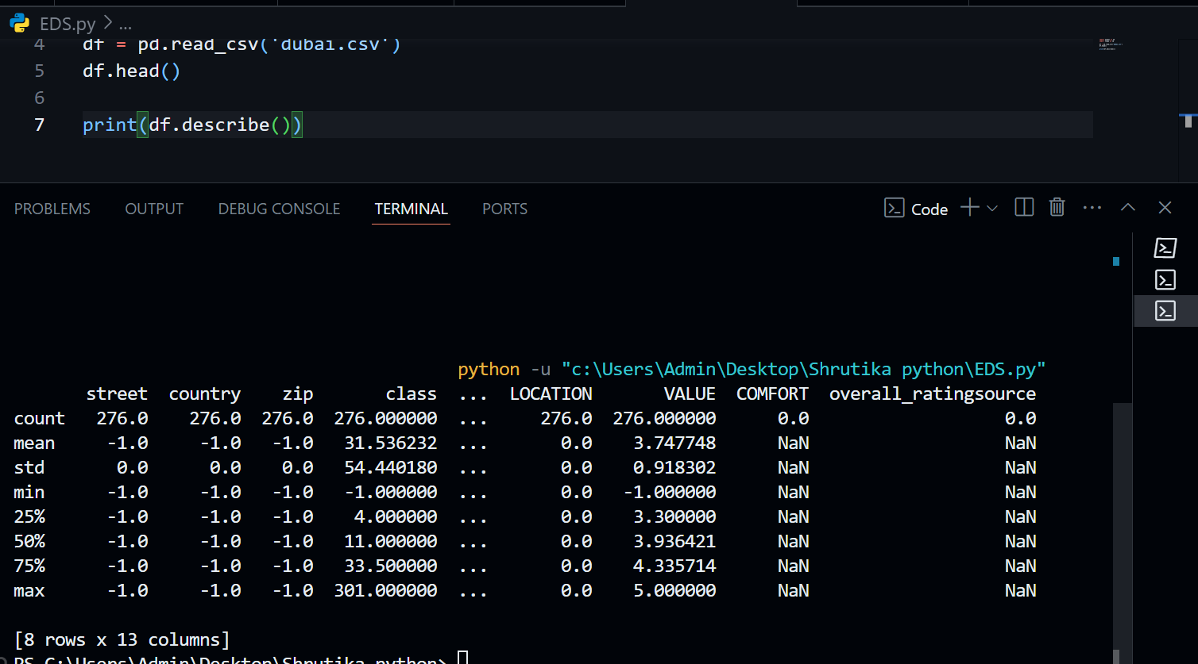

1. **Find how many unique hotel names are there.**

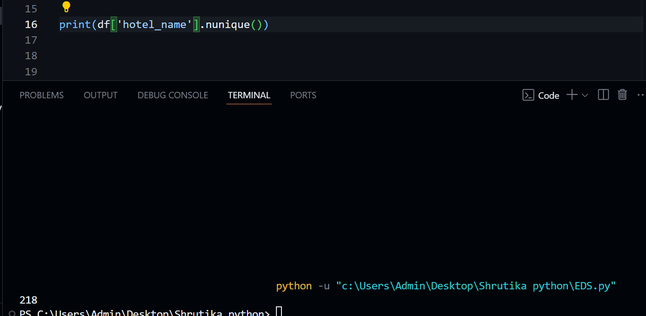

1. **List all unique city names in the dataset.**

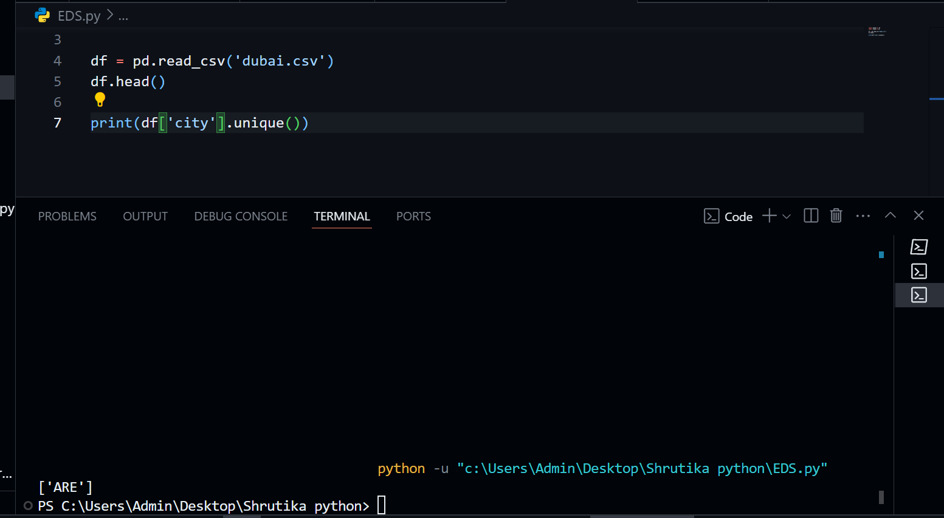

1. **Find the most common city in the dataset.**

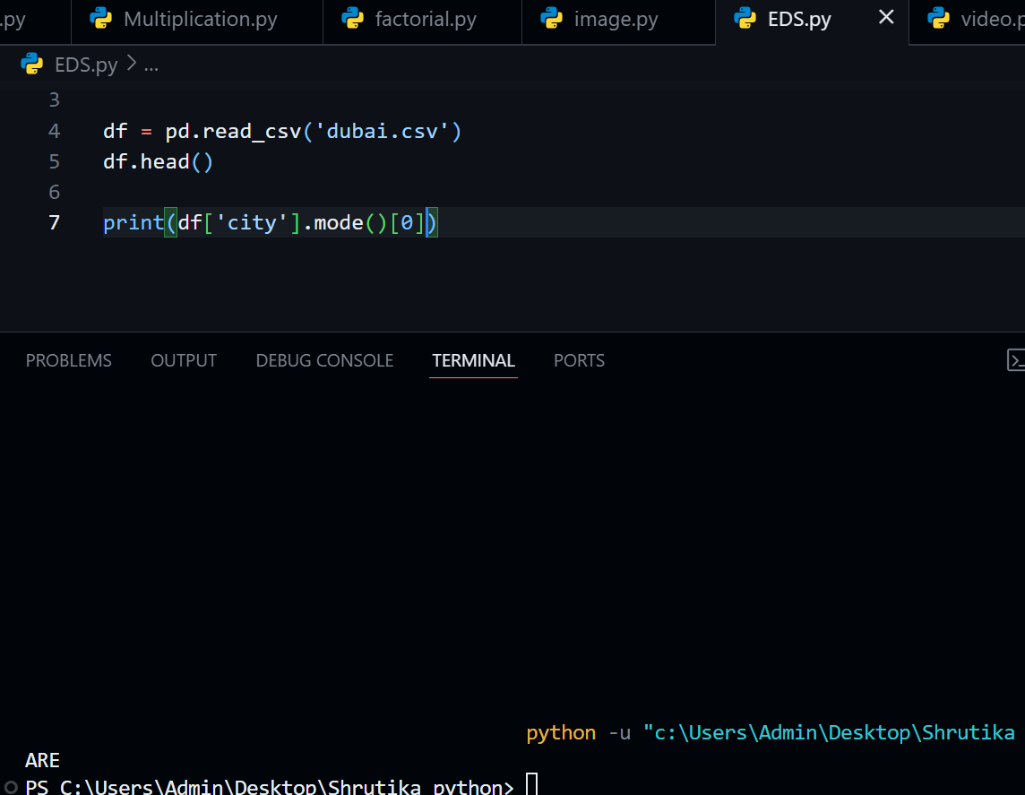

1. **Get all the reviews for hotels located in "Dubai".**

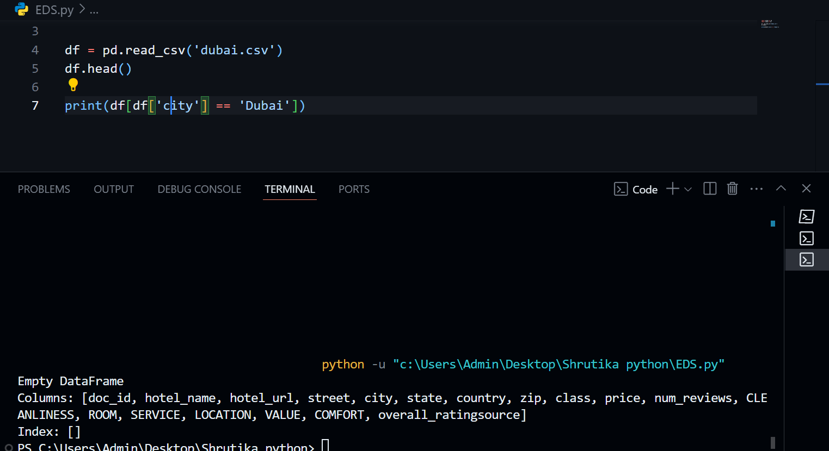

1. **Count how many hotels have the word "Resort" in their hotel name.**

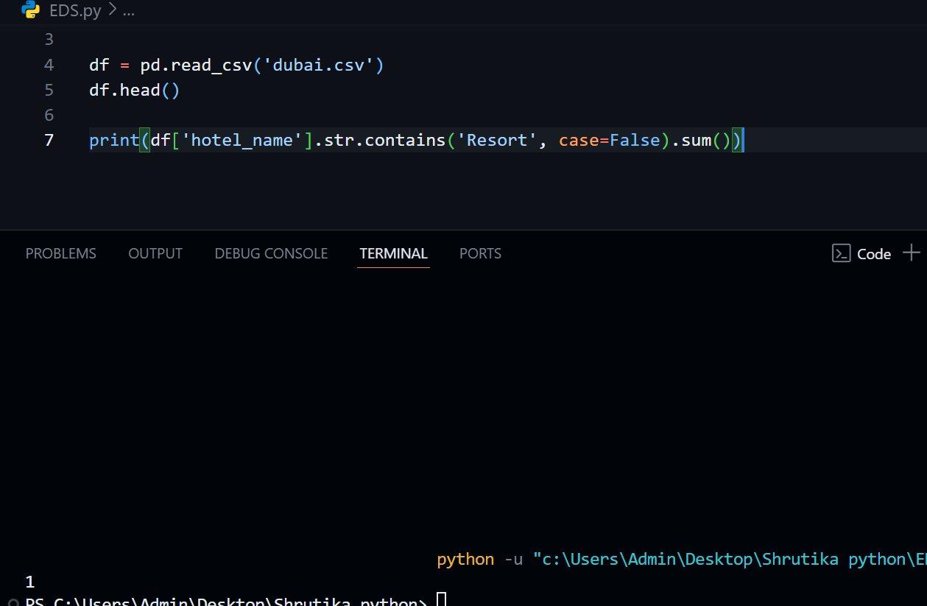

1. **Create a new column "Review_Length" that stores the length of each review text.**

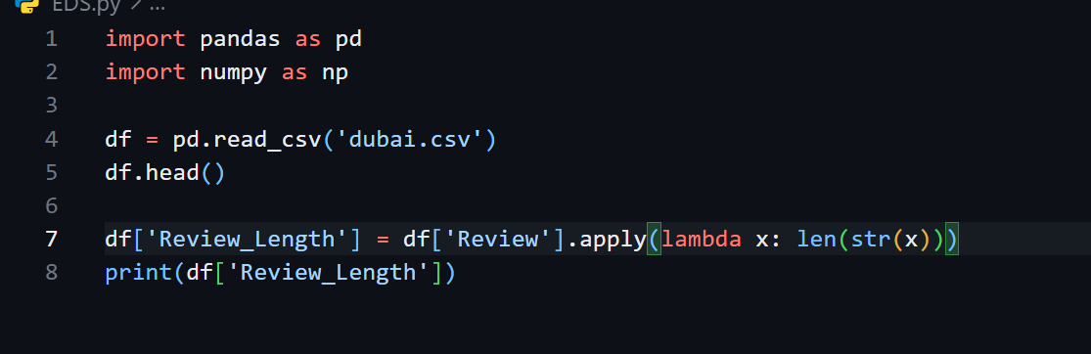

1. **Find the hotel with the maximum average rating.**

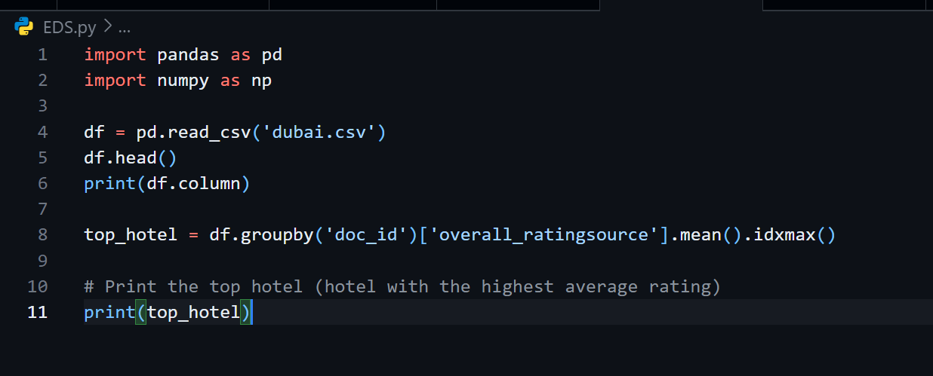

1. **Sort the dataset by "Overall_Rating" in descending order.**

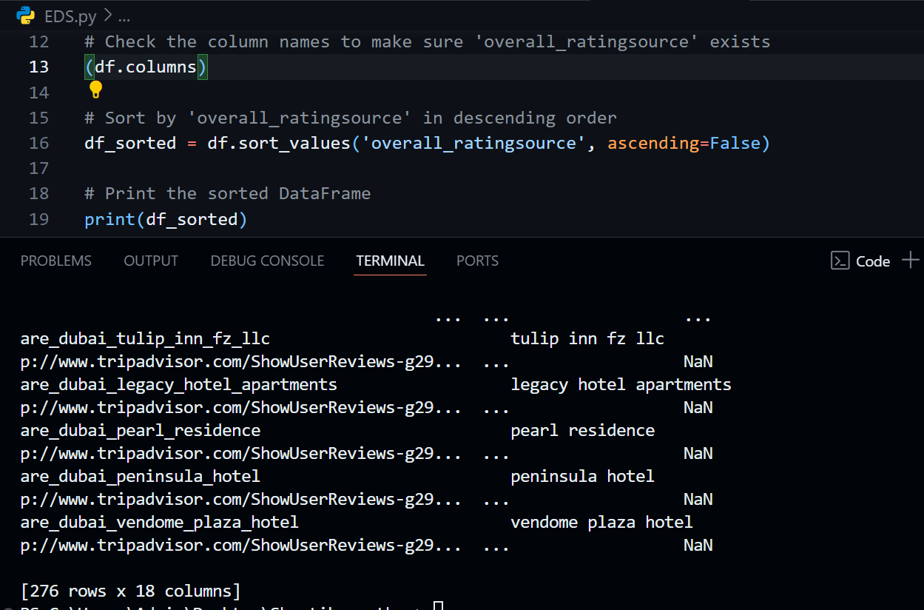

**15 Replace any missing or null values in the price column with the median price**

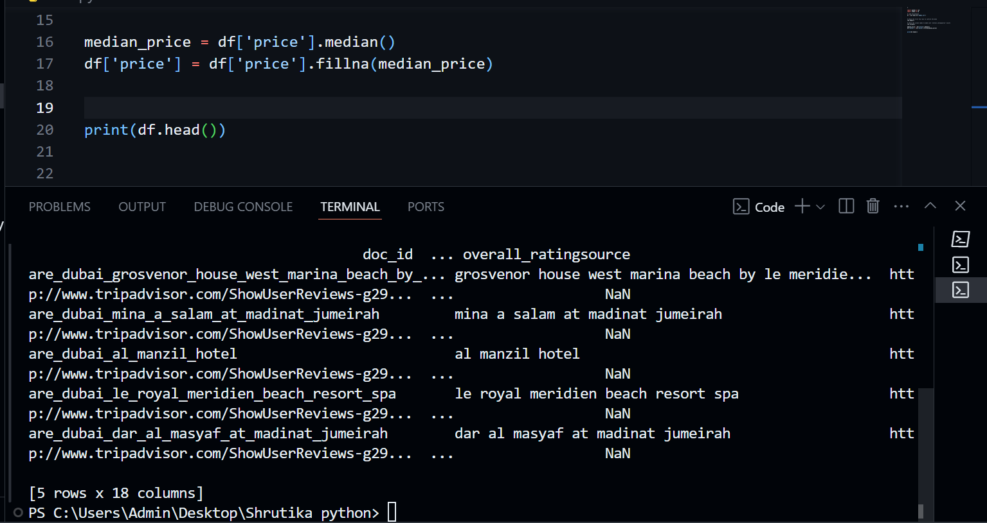

1. **Find how many reviews have an overall rating greater than 4.**

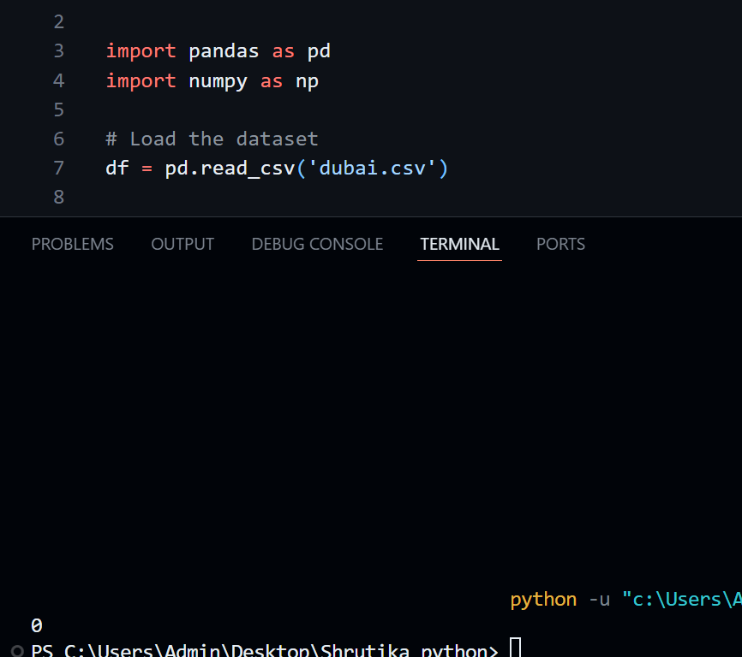

1. **Group by "City" and find the average rating per city.**

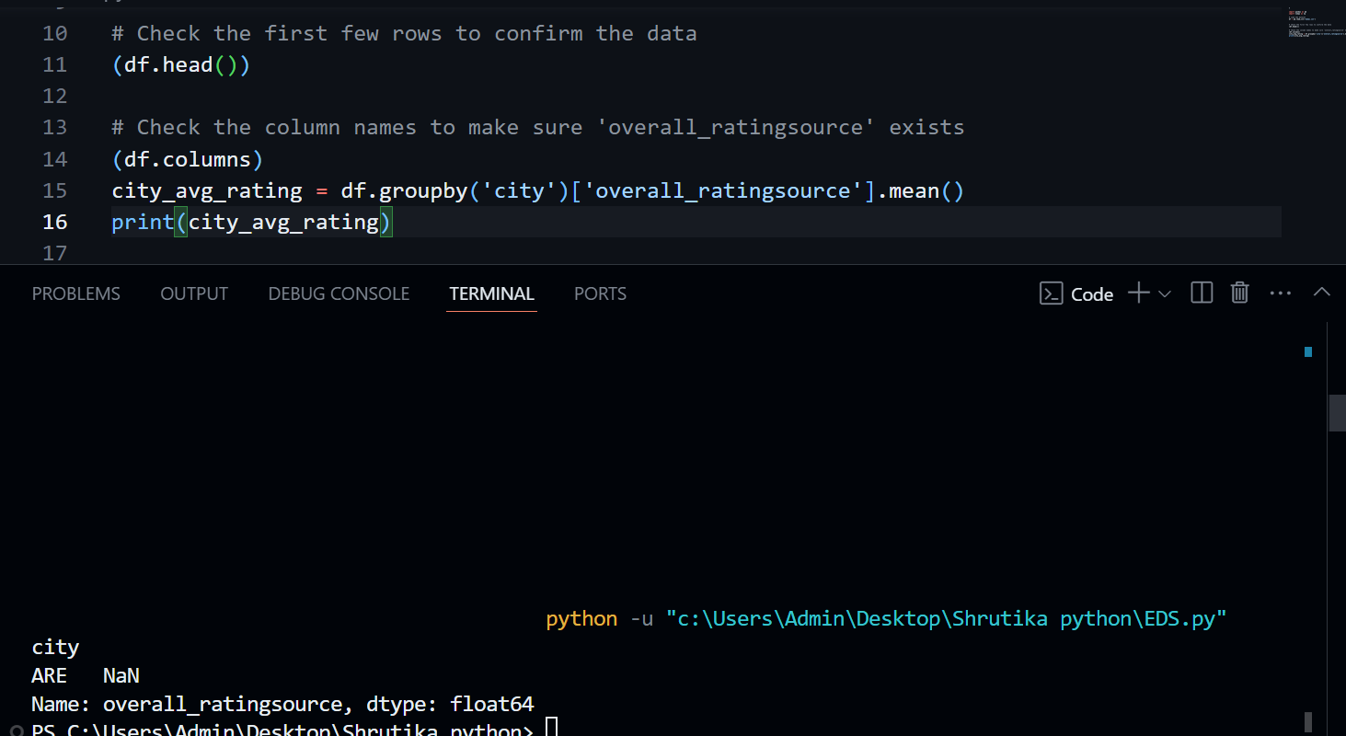

1. **Filter and show hotels with a rating between 3 and 5 only.**

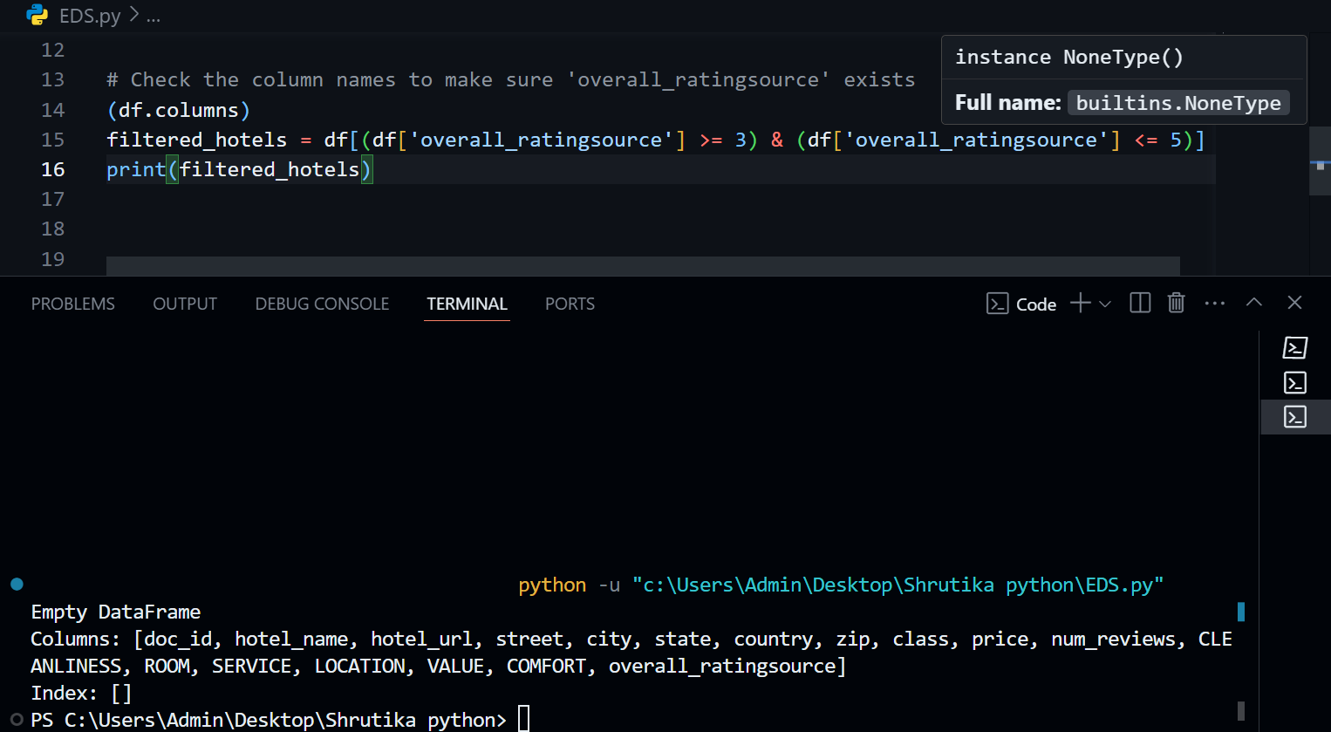

1. **Export the cleaned dataframe into a new CSV file called cleaned_dubai_reviews.csv.**

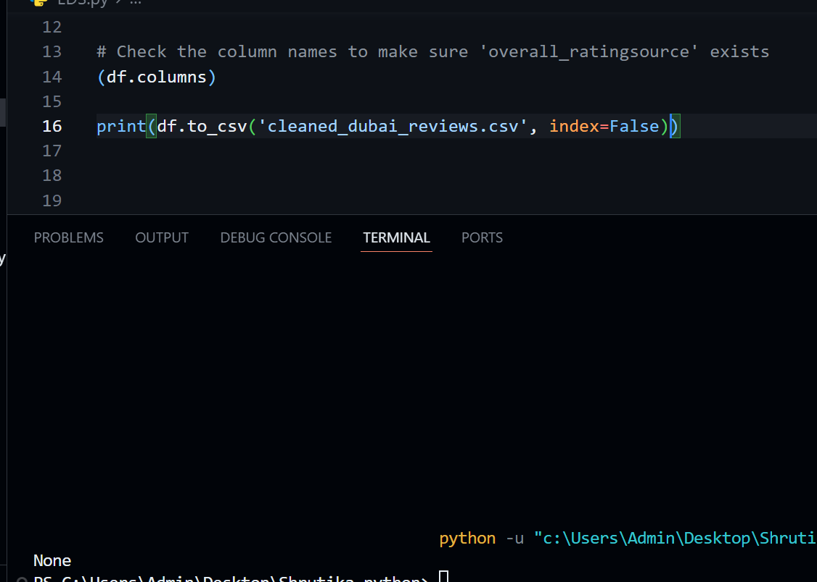

1. **F** **ind the most expensive hotel.**

